* **Azure:** Microsoft Azure is a cloud computing service created by Microsoft for building, testing, deploying, and managing applications and services through Microsoft-managed data centers.  
  Here services means resources that we consume.
* **What is service principal:**

An Azure service principal is a security identity used by user-created apps, services, and automation tools to access specific Azure resources. Think of it as a 'user identity' (login and password or certificate) with a specific role, and tightly controlled permissions to access your resources. It only needs to be able to do specific things, unlike a general user identity. It improves security if you only grant it the minimum permissions level needed to perform its management tasks.

* **Azure Feature:** 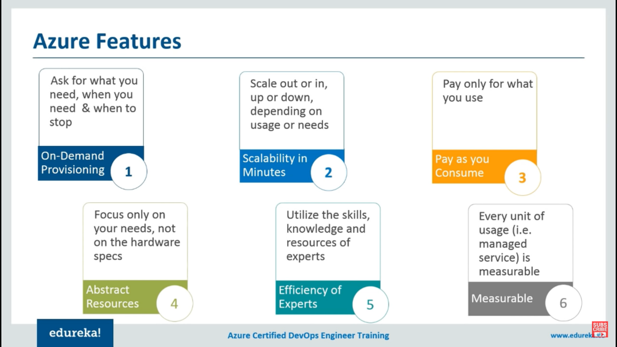
* **DevOps:** DevOps is a set of practices that combines software development (Dev) and information-technology operations (Ops) which aims to shorten the systems development life cycle and provide continuous delivery with high software quality.A set of practices intended to reduce the time between committing a change to a system and the change being places into normal production, while ensuring high availability.
* **Azure Boards:**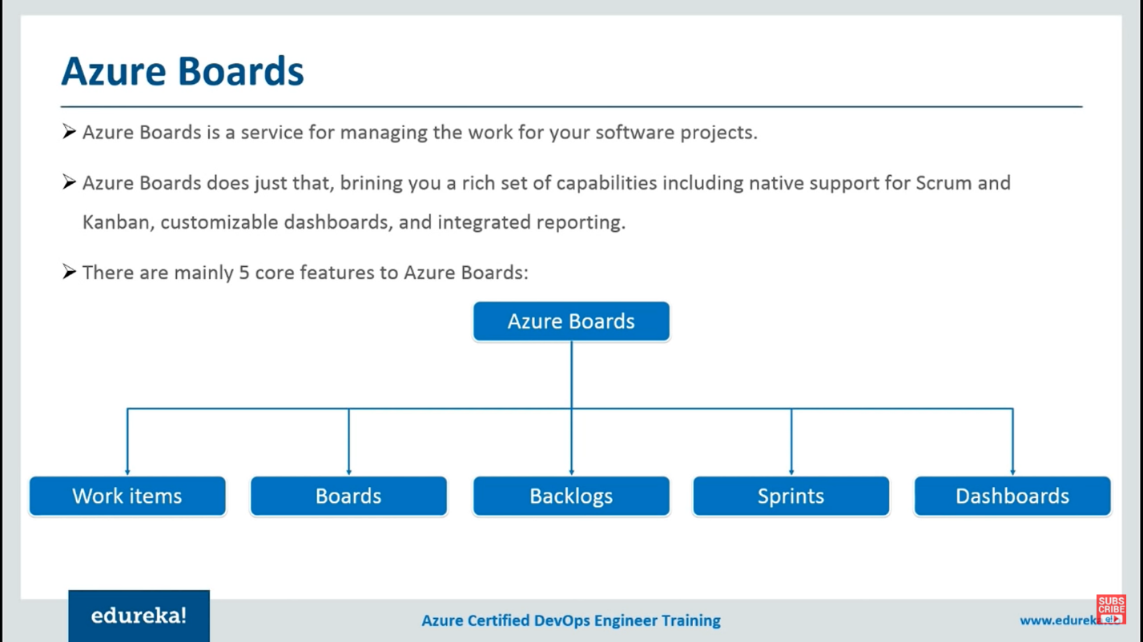
* **Azure Repo:**<https://docs.microsoft.com/en-us/azure/devops/repos/git/branch-policies-overview?view=azure-devops>  
  <https://docs.microsoft.com/en-us/azure/devops/repos/git/branch-policies?view=azure-devops>